**NORTHERN YOUTH FOOTBALL & CHEER**

**Board Meeting Minutes of May 30, 2024**

Location: Meeting conducted at Dillsburg VFW

***ATTENDANCE:***

**Members in attendance:**

Ed Whitt, Leah Simoncini, Ross Fronk Nichol Hare, Ben Hellmold, Matt Sadler,

**Members not present:**

Amanda Divittore, Brittany Hess, Danielle Peters, Kathy Walker, Tim Barrouk, Cody Lighty

**Attendance by non-members/public:** Dustin Hare

***WHEREAS*** the NYFC Board Meeting was called to Order by Ed Whitt at approximately 6:31p.m., who formally made a motion to begin along with a second motion.

**FOOTBALL: Ed Whitt + Ross Fronk**

* Meeting with Coach Thomas and Coach Gross and Midget Head Coach on April 20
* 300 mouthguards have arrived
* Equipment hand outs- we need an inventory day- Friday June 14th 6pm
* July 1st Midget/Pony and 2nd Peewee/Smurf equipment handout -Parent meeting 6pm; equipment pick up after.
* Helmets and pads at heat acclamation week
* Bostic field contract concerns- no weekday games and no make-up, smurfs would need to still be on the lower junior high field
* Anticipate school board meeting for decision on field use restrictions by June 25th. If restrictions are not lifted will NYFC will seek alternative venues.
* All coaches meeting June 17th 7pm Ed Whitt Home
* Scale needs calibrated
* Purchase paint for field lining
* Head coaches need to send coaching applications out to the assistant coaches- Ross will reach out to head coaches

**CHEER: Danielle Peters**

* Tumbling starts June 1-2 at Next Level
* Tumbling June 8-9 Flipping out tumbling
* Uniform fittings are June 18th and 20th
* Registration Numbers-

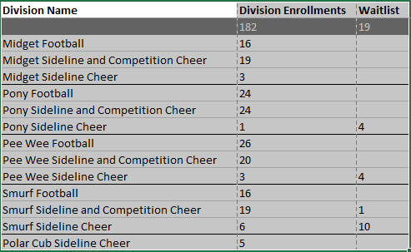

**TREASURER REPORT: Amanda Divitorre:**

* Brickers Check from Bingo - $128.30
* Brickers/Kona Ice are booked already for the upcoming season
* Portable Toilets for the season can't be booked until Mid June - I will call then.
* Erie Insurance has been paid for the year, payment was - $967.00
* Stauffers Flower Fundraiser money was depostited - $820.00, I wrote them a check for $500 not sure what the profit was?
* Taxes - Tony filed an extension for us so we are good until November. He reached out yesterday 5/29/2024 - He is currently working on them and should be in touch in the next few weeks. I'm thinking about $500+ based off last year.
* Registration this far for the New Season and Cheer Camp - $14,998.08 as of today 5/30/2024.
* Bank Account as of today 5/30/2024 - $44, 841.22

**FUNDRAISING: Nicole Hare**

**CFA Update-**

* USAfootball- insurance will give a grant back to the NYFC if we purchase
* “Sportsman raffle” instead of a gun raffle
* Sponsor packet to take to our sponsors?
* Weekend away raffle-donations from nearby hotels
* 2 people for money contact- treasurer and fundraiser
* Parents meeting should be required
* Booster night- players/cheerleaders go around town and ask for donations- does NYFC need a venmo?
* Volunteer check $150.00
* June 10th 7pm CFA registration meeting- BRITTANY
* Mother’s day fundraiser is going on Now - Hanging baskets and potted plants
  + Email was sent to 285 people
* Suggestion to look at doing bigger Fundraisers and cutting the smaller fundraisers
  + Local baseball team had a fundraiser with dinner, horse races, gambling, and a concert and made $6,000 with only having 11 kids on the team – Nicole will be reaching out to Ross to talk logistics
  + BINGO 2023 made close to $11,000
* Need to make parents aware of the cost it takes to run the program for a single year and get football families more involved in the preparation and operations
* Will be adding Nicole Hare as an admin on Game Changer to better be able to communicate to families about upcoming and current fundraisers

**CONCESSIONS: Cody Lighty& Kathy Walker**

* No report

**SPIRIT WEAR & PICTURE DAY: Leah Simoncini**

**OTHER POINTS OF INTEREST: None**

Next meeting will be TBD based on Bingo and CFA Meeting

**Board president-**

* NYFC donated $5000.00 to PBF for weight room equipment

**CFA Fund Raising Notes**:

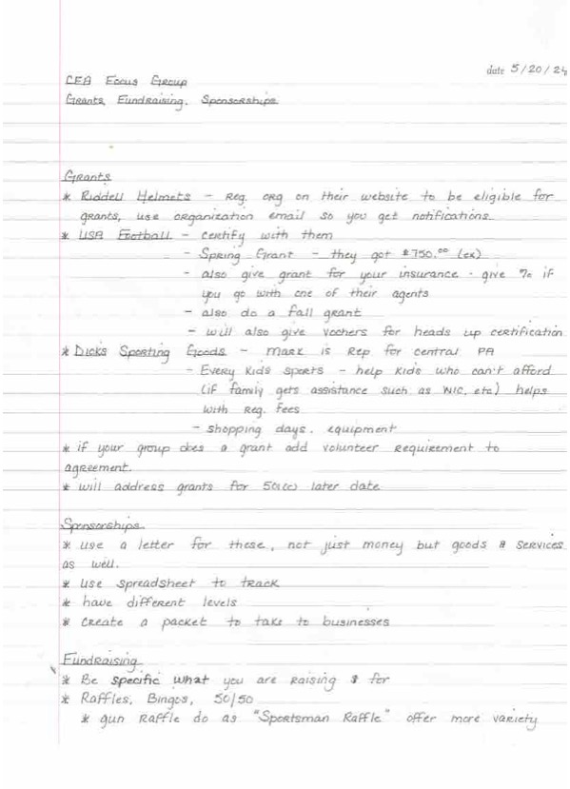

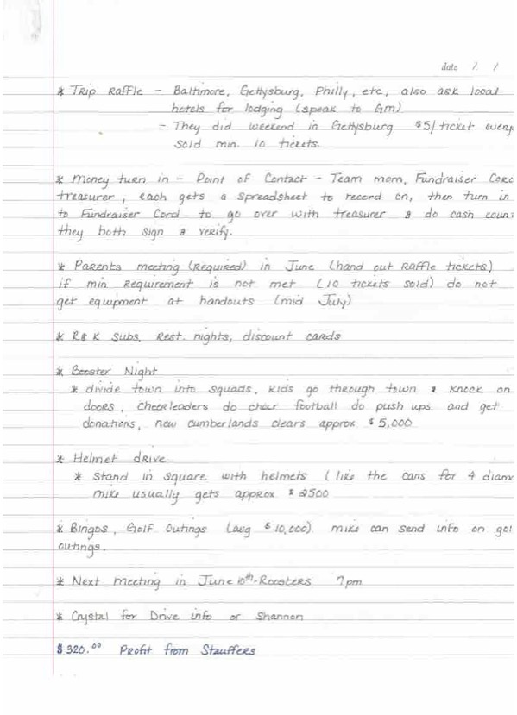

A motion was made by Ed Whitt to adjourn the meeting, a second motion was made, and all were in favor to conclude at 7:40pm.